PHASE 7: PROJECT DEMONSTRATION

7.1 Objective

The objective of the project demonstration is to demonstrate the complete working of the Auto Ticket Classification using Flow Designer system in ServiceNow.
The demonstration shows how a student or teacher creates an IT support ticket and how the system automatically identifies the issue, assigns the appropriate Category and Subcategory, and sends an email notification to the caller.

7.2 Demonstration Environment

The project is demonstrated using:
- Platform: ServiceNow
- Application: Global
- Table: Incident Workflow
- Automation: Flow Designer
- Flow Name: Auto Classify School IT Tickets
- Notification: Send Email action
- Classification Method: Keyword-based conditions

7.3 Demonstration Workflow
The complete demonstration follows this sequence:

Open Incident Workflow
↓
Create New Ticket
↓
Select Caller
↓
Enter Short Description
↓
Save Ticket
↓
Flow Designer Trigger Executes
↓
Keyword is Identified
↓
Category Automatically Assigned
↓
Subcategory Automatically Assigned
↓
Email Notification Sent
↓
Verify Ticket and Email

7.4 Demonstration – Wi-Fi Issue

Step 1: Open the Incident Workflow Table
Navigate to:
All → Search → Incident Workflow
Open the custom Incident Workflow table.
Click the New button to create a new IT support ticket.
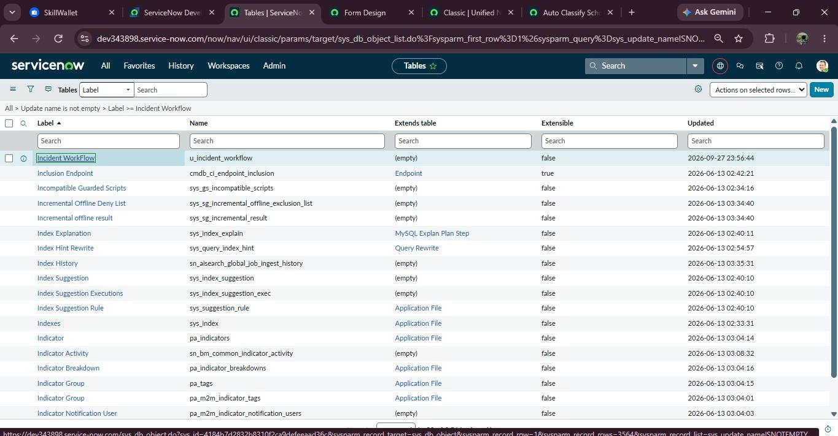
Figure 7.1: Incident Workflow table used to manage school IT support tickets.

Step 2: Create a New Ticket
Enter the required information.

Caller
Select a student or teacher from the Caller reference field.

Short Description
Enter:
WiFi not working in library

Description
You can enter:
The WiFi connection is not working in the library.
The user does not manually select the Category or Subcategory.

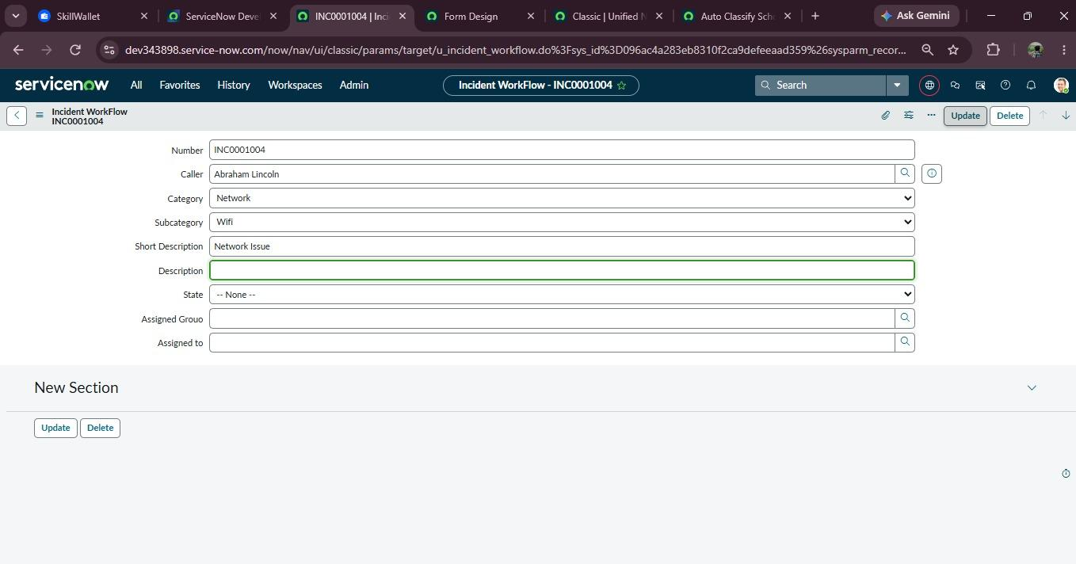
Figure 7.2: New IT support ticket created with the caller and issue description.

7.5 Save the Ticket
Click Submit/Save.
When the ticket is created, the Record Created trigger in Flow Designer is activated.
The flow checks whether the Category is empty.
Since the Category is empty, the flow proceeds to keyword classification.

7.6 Automatic Wi-Fi Classification
The Flow Designer checks the Short Description.
The entered text is:
WiFi not working in library
The flow identifies the keyword WiFi.
The corresponding condition is:
Short Description contains WiFi
The Update Record action automatically sets:
Category = Network
Subcategory = Wi-Fi
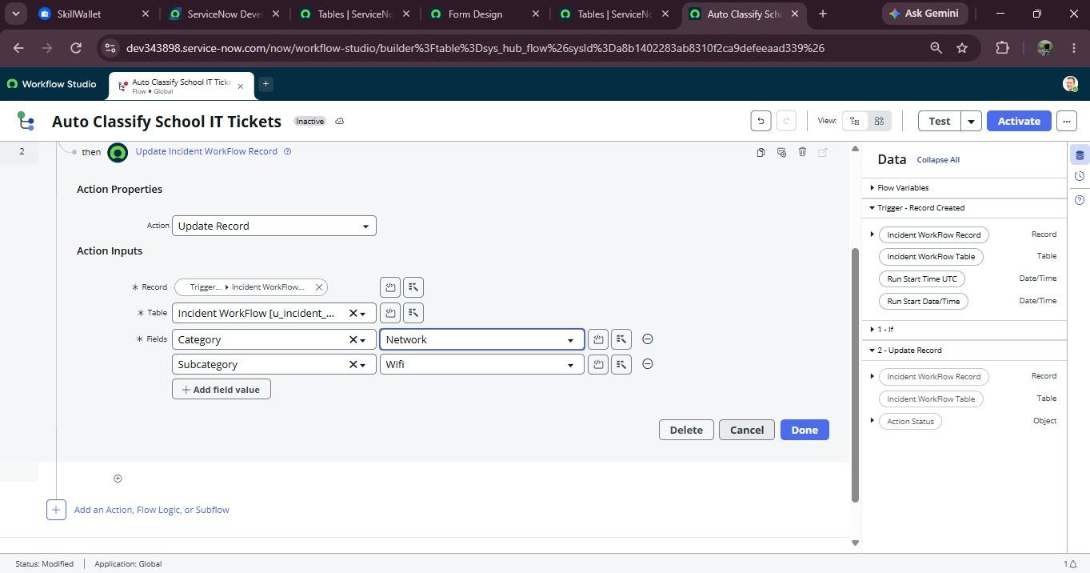
Figure 7.3: Ticket automatically classified as Network and Wi-Fi.

7.7 Automatic Email Notification
After classification, the Flow Designer executes the Send Email action.
The email is sent to:
Caller → Email

Subject
Your IT Support Request Has Been Submitted

Email Body
Dear Caller,
Your IT support request has been successfully submitted.
Our support team will review your request and take the necessary action.
Thank you,
School IT Helpdesk

7.8 Demonstration – Projector Issue
To verify that the automation works for another type of issue, create a second ticket.

Caller
Select a student or teacher.

Short Description
Enter:
Projector not turning on

Description
Enter:
The projector in the classroom is not turning on.
Click Submit.
The Flow Designer detects the keyword:
Projector
The flow automatically assigns:
Category = Hardware
Subcategory = Projector
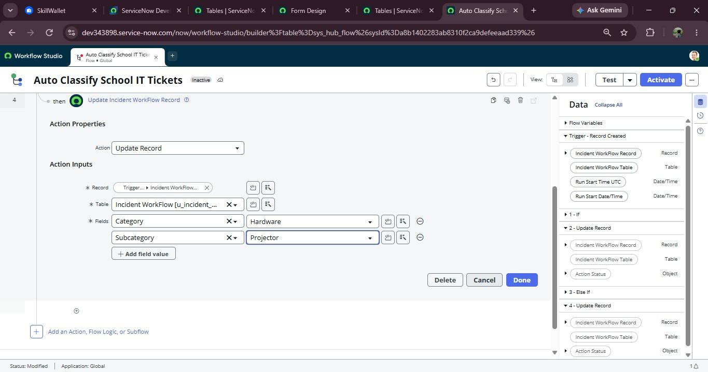
Figure 7.5: Projector support ticket automatically classified as Hardware and Projector.

7.9 Demonstration – Password Issue
Create another ticket.

Short Description
Forgot my password
The Flow Designer detects:
Password
The ticket is automatically updated as:
Category = Access
Subcategory = Forgot Password

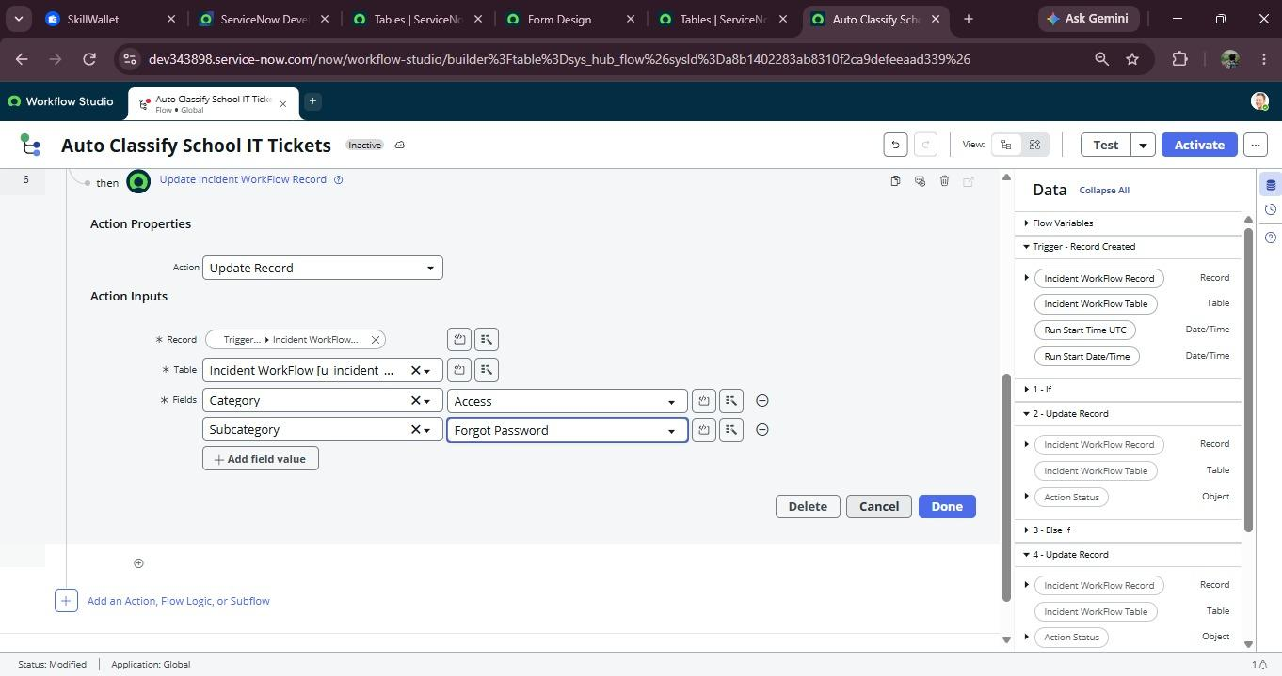
7.6: Password-related ticket automatically classified under Access.

7.10 Demonstration – Slow Computer Issue
Create another ticket.

Short Description
Computer is very slow
The Flow Designer detects:
Slow
The ticket is automatically updated as:
Category = Performance
Subcategory = Slow Computer

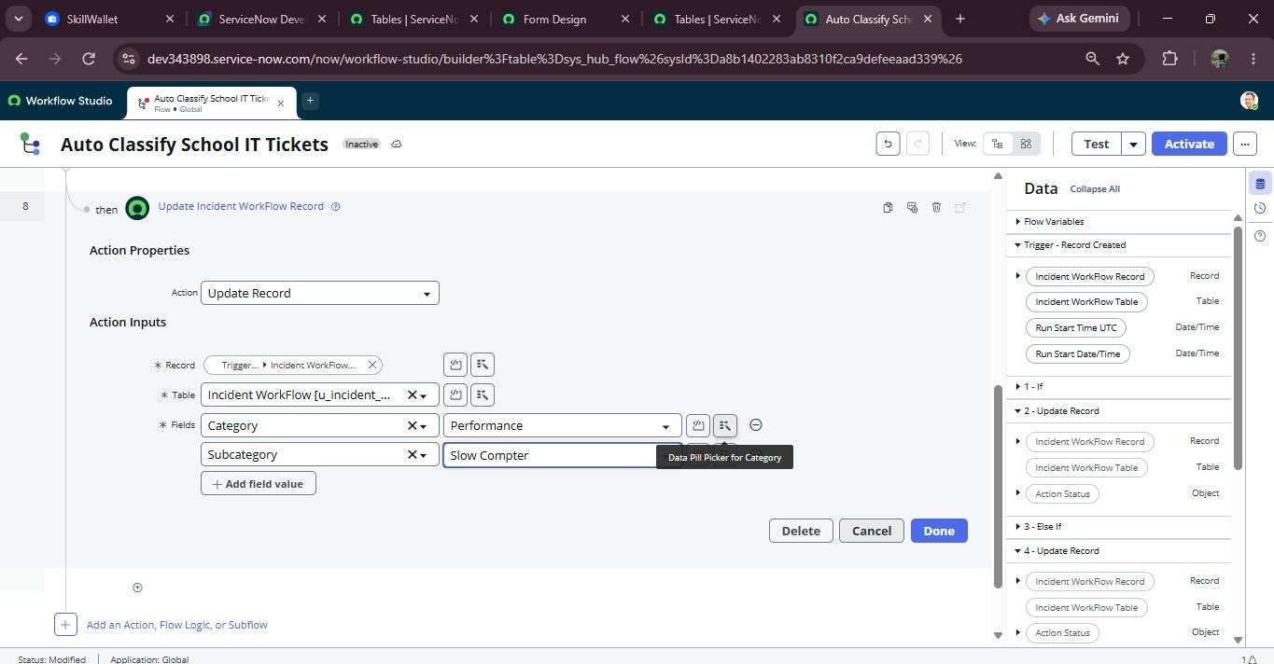
Figure 7.7: Slow computer ticket automatically classified under Performance.

7.11 Classification Results
The demonstration produces the following results:
Test Input | Keyword Detected | Category | Subcategory
WiFi not working in library | WiFi | Network | Wi-Fi
Projector not turning on | Projector | Hardware | Projector
Forgot my password | Password | Access | Forgot Password
Computer is very slow | Slow | Performance | Slow Computer
This confirms that different types of IT support requests are automatically classified according to the predefined Flow Designer conditions.

7.13 Demonstration of Flow Designer
Finally, open:
All → Process Automation → Flow Designer
Open:
Auto Classify School IT Tickets
Show the complete flow containing:
- Record Created Trigger
- Category is Empty condition
- WiFi/Network condition
- Projector condition
- Password/Login condition
- Slow/Hanging condition
- Update Record actions
- Send Email action
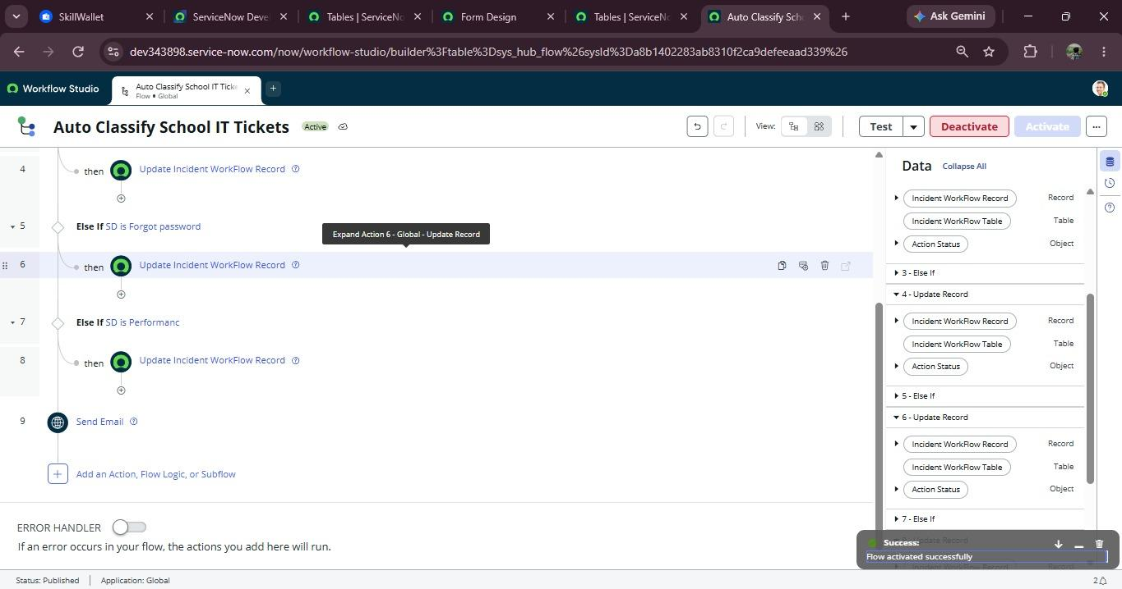Figure 7.9: Complete Auto Ticket Classification flow implemented using Flow Designer.

7.16 Conclusion
The project demonstration successfully shows the complete working of the Auto Ticket Classification using Flow Designer system. The system accepts an IT support request, analyzes the short description, automatically assigns the appropriate Category and Subcategory, and sends an email notification to the caller.
The demonstration confirms that the implemented solution provides a structured and automated approach for handling common school IT helpdesk requests using ServiceNow Flow Designer.

